Classroom activity

A disturbance in the Force gives insights in beam diagnostics

Simulating the effect of a skimmer using sand and cardboard
This exercise shows how ‘skimmers’ can be used to modify the gas jet.

Aims
- To replicate the effect of skimmers on a gas jet by using sand passing through gaps in cardboard.
- To understand how changing the diameter of the skimmers and the number of background particles affect the number of particles that propagate through the system.

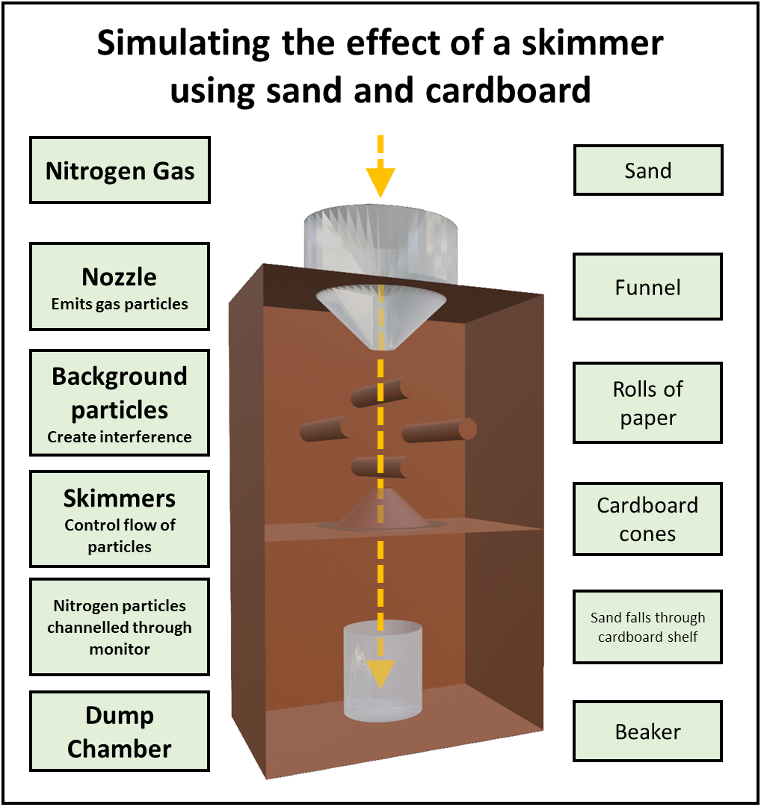
Skimmer exercise
Cockcroft Institute

Equipment
- Standard-size cardboard box, such as a shoebox
- Paper
- Scissors and tape
- A 200ml measuring beaker of sand
- Empty 200ml measuring beaker
- Funnel

Method
- Stand the shoebox on one of the short ends. Cut a hole in the opposite end – this should be large enough so that the funnel can be inserted into the hole without it falling through.
- On the paper, draw three circles of equal sizes, cut them out and make a cut from the edge to the centre. Twist the paper to create a cone and secure with tape.
- Cut varying amounts from the tips of the cones, so that the diameter of the hole in the tip is different for each cone (small, medium, large). These are your skimmers.
- From the lid of the shoebox, cut a piece to make a shelf. It should fill the width of the box, leaving a little extra to bend down.
- Cut a hole in the cardboard shelf that is just slightly smaller than the diameter of the wider end of the cone and then tape the shelf into the box, approximately halfway down.
- Place one of the skimmer cones on the shelf.
- Place the empty beaker below the hole in the shelf.
- Pour all the sand through the funnel.
- Measure the amount of sand that reaches the lower beaker.
- Repeat for each cone size.

Extensions
Add rolls of paper to the inside of the box to simulate background particles that can create noise.
Decrease the diameter of the final beaker to show how letting more particles through is not always effective in creating a uniform beam

