Classroom Material

Build your own virtual accelerator

What does each component of the accelerator do?

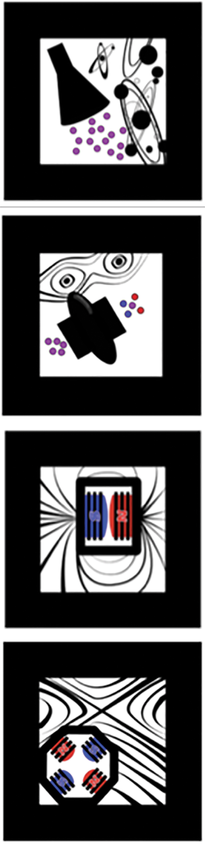
The particle source creates the particles, such as protons, to be accelerated. As these particles are charged, they respond to electric and magnetic fields.

The radiofrequency (RF) cavity is a chamber that contains a time-varying electromagnetic field. When the particles pass through, they receive an impulse that accelerates them.
Dipole magnets are magnets, in which the north and south poles are on opposite sides. In particle accelerators, they are used to bend a beam of charged particles. They are particularly useful when the beam needs to go in a circle, for example, in the Large Hadron Collider (LHC).
Quadrupole magnets consist of four magnets arranged in a cross pattern. Together, they create a magnetic field that can squeeze the particles together, focusing the beam at regular intervals.
acceleratAR

Dipoles and quadrupoles

How do dipoles work?
Dipoles are magnets with two poles used to generate a constant magnetic field that flows from north to south. A charged particle inside the magnetic field will be deflected along a curved path because the magnetic field will imprint a force, the direction of which is perpendicular both to the velocity of the charge and the magnetic field.
The right-hand rule can help you to visualize the direction in which the force will act on a charged particle.
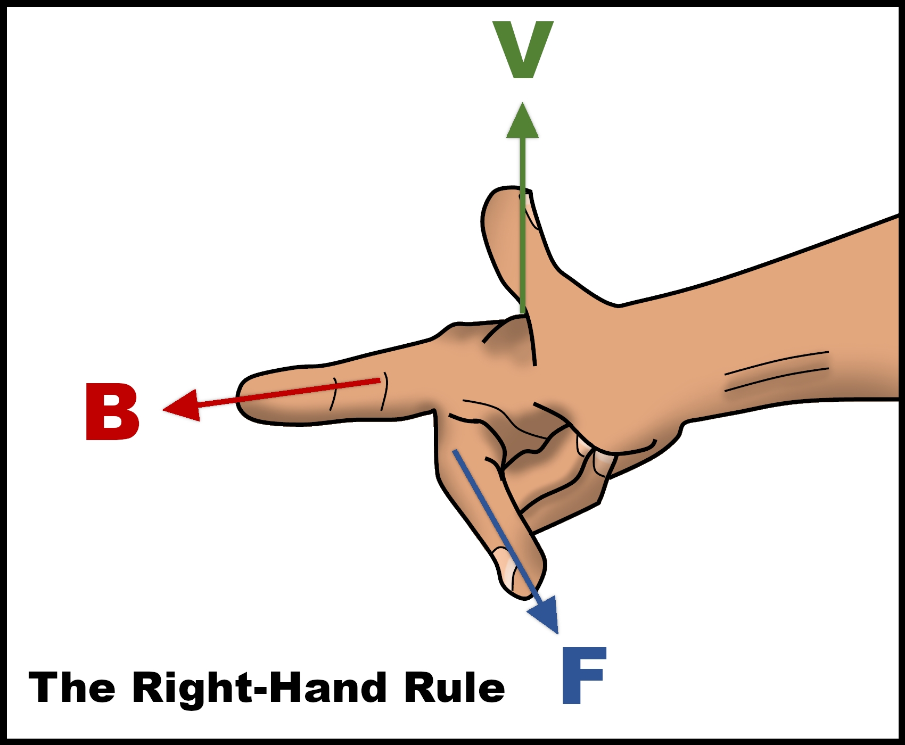
The right-hand rule
In the image, V corresponds to the direction in which the particle is moving and B to the direction of the magnetic field. The force that a particle will feel inside the magnetic field will be in the direction of F.
Try to work out which direction the magnetic field is moving in the virtual dipole. Use the right-hand rule, the direction in which the particles are moving, and the direction in which particles are being pushed.
Department of Physics/University of Liverpool
Why do we need to focus the beam?

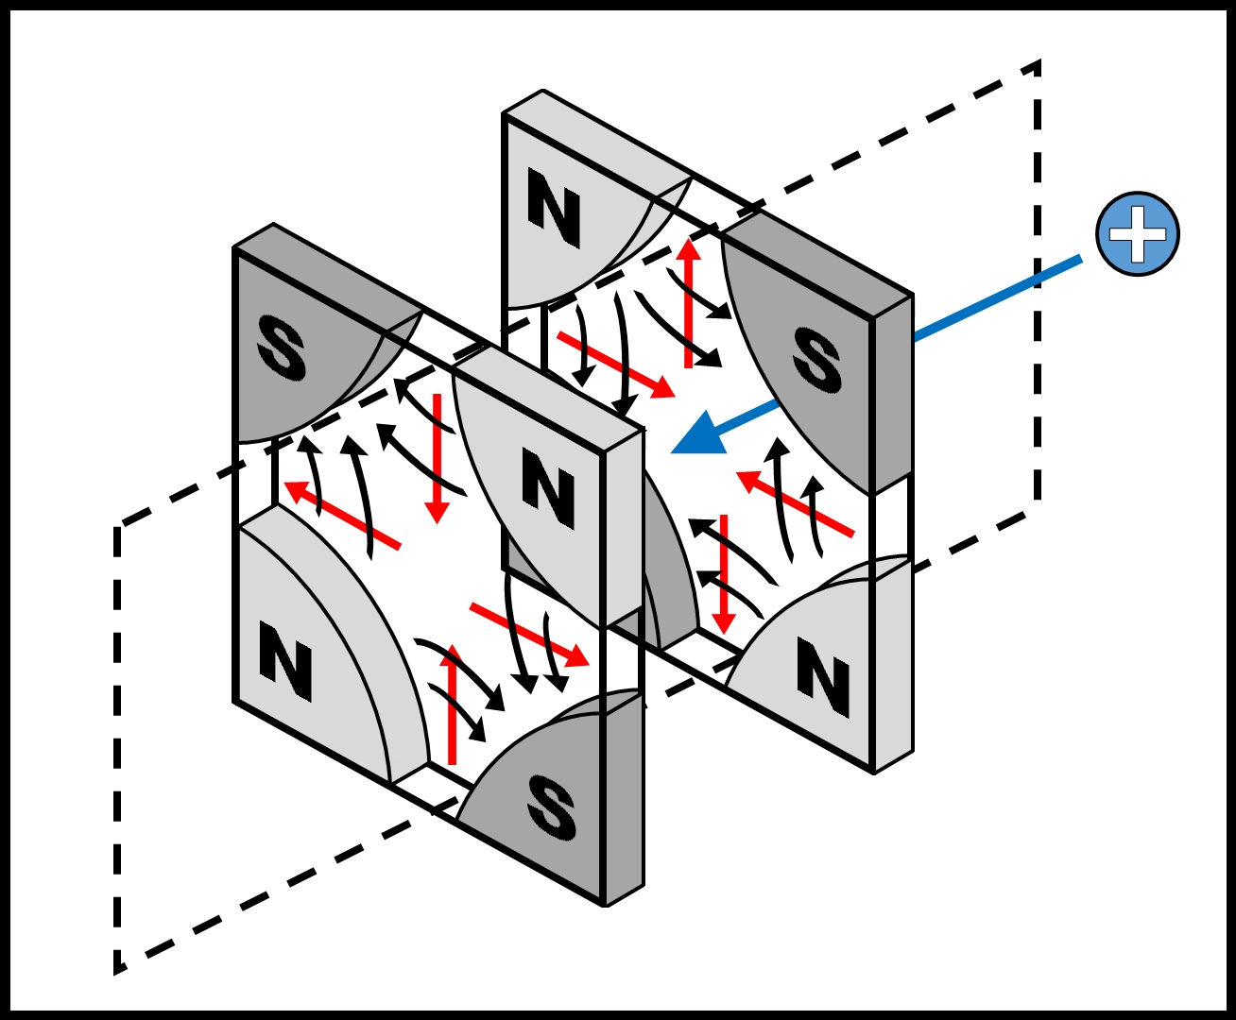
Remember that protons are charged particles. Also, like charges repel each other. This means that a beam of protons will diverge and may escape the vacuum chamber, unless an external force is applied to constrain their height and width. This is achieved by making the beam pass through a magnetic quadrupole.
The direction of the quadrupole’s magnetic field is given by the black arrows. The red arrows represent the direction of force on a positive charge.
The positively charged particle on the right will pass the first quadrupole, which will squeeze it horizontally and constrain its width. A second magnet, in which the poles are flipped, will constrain the particle’s height.
Department of Physics/University of Liverpool
A quadrupole is always focusing in one plane and defocusing in the perpendicular plane. A combination of several quadrupoles can provide an overall focusing effect on a charged particle beam.

Further information

Q&A provided by the Department of Physics University of Liverpool

Q. Where do source particles come from?

A. The LHC at CERN is used to accelerate protons, but where do they come from? They come from a tank of hydrogen that has been showered by an electric field to break down the atoms and strip out the electrons.

Q. Why is it called radiofrequency cavity?

A. This is because RF cavities deliver radiofrequency power to the beam which in result gets accelerated. The radiofrequency at the LHC is 400 MHz (400 million oscillations per second).

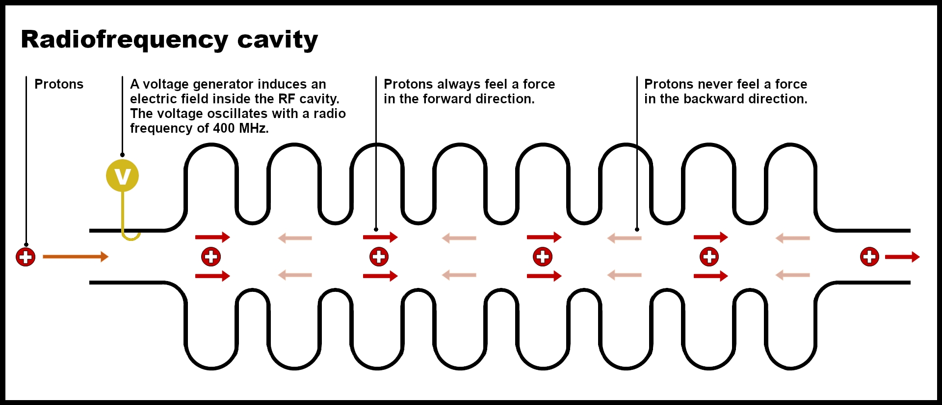
Department of Physics/University of Liverpool

Q. Up to which speed have particles been accelerated?

A. The speed of light is c = 299,792,458 m/s, and particle accelerators have been able to accelerate particles up to 299,792,457.9964 m/s. This is 0.99999999998799 c!

Q. How do quadrupoles work?

A: Quadrupoles are formed by four magnets in a cross-like shape, whose magnetic field increases from their centre to the outside. Because the direction of the magnetic field is not constant in a quadrupole, the direction of the force it exerts on a charge varies.
Q. What is the Higgs Boson?

A: Before we move to the Higgs boson, let’s clarify what a boson is. Bosons are fundamental particles, i.e., they don’t have any substructures and are the building blocks of other particles.

The standard model is a theory that describes how three fundamental forces – weak, strong, and electromagnetic – work and interact (the fourth fundamental force is gravity, but that one is described by the theory of general relativity). It also classifies the fundamental particles (bosons, leptons, quarks, etc.). A question that scientists had was why some particles like photons had no mass, while others were quite heavy.

Q: What determines the mass that particles have?

A: In the 1960s five scientists (including Peter Higgs) proposed that the universe was filled with the “Higgs field”, and that the way particles interacted with this field determined their mass. For light particles like electrons, interaction with the Higgs field is like running on a flat surface with no obstacles, whereas for heavy particles like the muon (the electron cousin) moving in the Higgs field is like swimming in water. For the heaviest particle, the top quark, moving in the Higgs field is like swimming in honey. The “resistance” that particles experience from the field is what gives them mass. Since photons do not interact with the field, they don’t have mass.

All the fundamental forces have an associated particle that acts as a “messenger”. For example, photons are the fundamental particles of electromagnetic forces: they transfer electromagnetic forces between charged particles. The Higgs field also has an associated particle that is the Higgs boson. Therefore, when scientists detected this particle in 2012, they proved the Higgs field theory, and how its interaction with particles gives them mass.

In short, the Higgs boson is a manifestation of the Higgs field that gives mass to particles.

