Practical notes

Little wonder: pH experiments the microscale way
1 – Delivering drops
3 cm³ and 1 cm³ Pasteur pipettes, which deliver about 20 and 30 drops per cm³, can be used for this purpose.
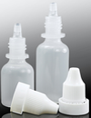
One issue is how to clean and dry the pipettes. If a pipette, which has been emptied of reagent, is washed with water three times by sucking water up, inverting the pipette, and emptying the contents into waste, the contaminating chemical is removed. Damp pipettes can be reused for qualitative work. If they are required to be dry for quantitative work, then suck up a little ethanol, invert the pipette, swirl, and then expel contents to the waste. These pipettes will dry very quickly. This is a useful lesson in sustainability for students, as there is much concern about plastic waste.^{[1]}
Dropping bottles can be bought, and reagents keep very well in them. However, dilute solutions containing iron(II) salts, bromine, chlorine, starch, ammonia, and hydrogen peroxide have a limited shelf-life of a month or so. Buffer solutions can develop mould and benefit from being kept in a fridge.

References

[1] A video on how to clean a pipette: https://www.youtube.com/watch?v=kx1gC4wHryQ .

2 – Making buffer solutions
A reference table for making buffer solutions from available chemicals for various pH values is given below.
pH value | Method
1 | Use 1 M hydrochloric acid
2 | Use 0.01 M hydrochloric acid
3 | Add 0.1 M ethanoic acid to pH buffer 4 and gently stir with the pH probe until the meter reads “4”
4 | Use pH 4 buffer
5 | Add pH buffer 7 to pH buffer 4 and gently stir with the pH probe until the meter reads “5”
6 | Add pH buffer 4 to pH buffer 7 and gently stir with the pH probe until the meter reads “6”
7 | Use pH 7 buffer
8 | Add pH buffer 9 to pH buffer 7 and gently stir with the pH probe until the meter reads “8”
9 | Use pH 9 buffer
10 | Add 0.1 M sodium carbonate solution to pH buffer 9 and gently stir with the pH probe until the meter reads “10”
11 | Add pH buffer 9 to 0.1 M sodium carbonate solution and gently stir with the pH probe until the meter reads “11”
12 | Add 0.1 M sodium hydroxide solution to 0.1 M sodium carbonate solution and gently stir with the pH probe until the meter reads “12”
13 | Use 0.01 M sodium hydroxide
14 | Use 1 M sodium hydroxide (wear eye protection!)
pH 4, 7, and 9 powders can be obtained from educational suppliers, online, or from suppliers of aquarium and garden materials.
The shaded pH values can be made or used very easily by students, teachers, or technicians. If buffers of intermediate pH values are required, then a pH meter is required. Eye protection is required.

3 – Making a Worksheet Template
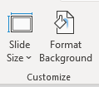
Set up PowerPoint or any other slide-making program on your computer. This has proved to the most convenient method of making worksheets because the diagrams/pictures and text boxes can be moved about.
• Open a blank slide.
• Click on ‘Design’ and find the slide size icon.
• Move to ‘Customize’.
• At ‘Slides sized for’, select ‘Slides for A4’, and you can choose portrait or landscape.
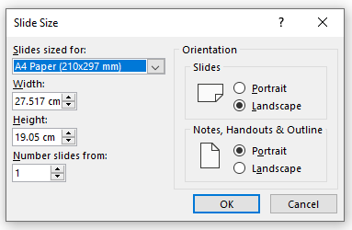
‘Shapes’, e.g. 1.5 cm circles and ‘text boxes’, are used to add instructions and questions. These can now be inserted on the slide. This section is very useful, particularly the ‘Align’ function, for designing the worksheet.
When satisfied with the slide, save it as both PowerPoint and JPEG files.
Print the JPEG file on paper.
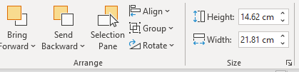
This paper is inserted into a plastic wallet or folder. It can be laminated, but that prevents you from making any alterations.

