Science in School – issue 29
Light refraction in primary education: the solar bottle bulb
The shoebox experiment

The theoretical laws of refraction can easily be exemplified with a shoebox. The experiment should be done in groups of two to three pupils. Depending on the pupils’ age and on how much time the lesson offers, the teacher could also prepare the shoeboxes beforehand in order to shorten the time dedicated to handicraft work in class.

The experiment on the one hand shows how refraction of light works and on the other hand provides solutions to the question of why everything is blurry when we are under water. The topic of light refraction can be introduced by showing a picture of a straw or pencil in a glass of water to the students. If the picture is taken from the side, it looks as if the straw or pencil is broken, which is a good basis for generating questions.

Materials
- Utility knife
- Shoebox (without top)
- Clear glass
- Water

Procedure
- Carefully cut two vertical slits into the short end of the shoebox. The space between the slits should not be wider than the glass.
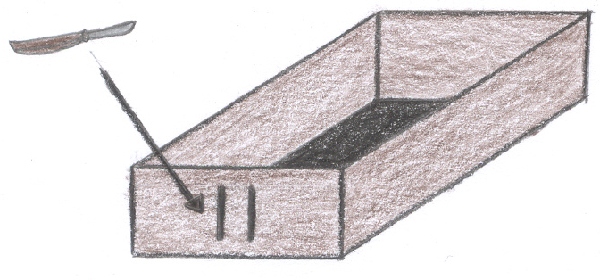
- Darken the room and let the torch shine into the box through the slits. What do you see?
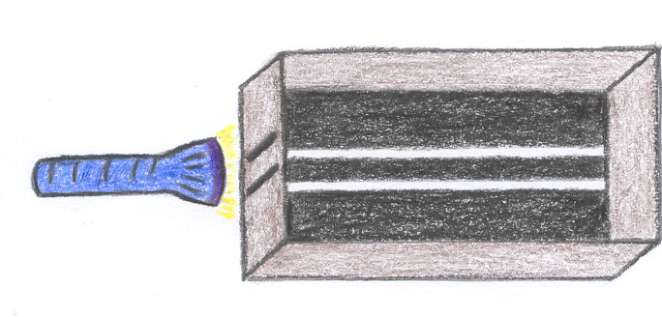

- Now pour water into the glass and place it in the box behind the two slits. Repeat step 2. What do you see this time?
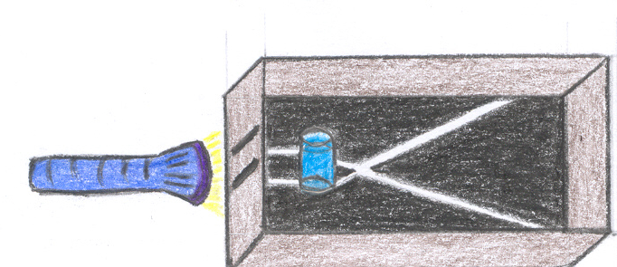

Results
Without the glass of water the light rays entering the box are parallel and clear.

When the glass of water is placed behind the slits, the light rays become blurry and cross each other. This is the result of the light being slowed down by the water, as it has a higher optical density than air. According to the law of refraction, the angle in which the light is bent is smaller relative to the normal angle and thus the two light rays eventually cross.

These results are a good basis for attempting to answer why things seem blurry under water. The explanation is straightforward considering the theoretical background and the fact that our eyes are optimized for seeing in air. When a light beam under water enters your eye, there is a change of medium and the light beam is bent (that wouldn’t happen for a light beam in air entering your eye). As a result, the sharp image of reality is not projected onto the retina but behind it. Strictly speaking, we are long-sighted under water and therefore everything seems blurry. Diving goggles help to restore sharp vision by preventing direct contact of water and eye so that air-like conditions of vision are guaranteed.

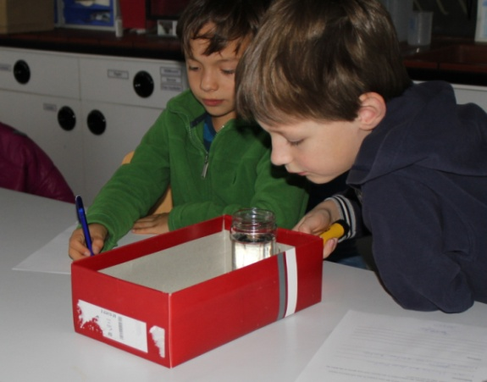
Didactic Note
Figure 1. Students trying out the Shoebox-Experiment. The student on the left is the writer and the one on the right the conductor.
When conducting this experiment it proved handy to allot different roles to the students within their groups (see Figure 1), for example: an observer, a writer and a conductor. The observer watches the experiment carefully in order to help the writer fill in the observation sheet, he can also manage the time. The writer will also read the instructions to the conductor, who is in charge of performing the instructions and making sure that the whole experiment works out properly. This procedure helps to develop a sense of responsibility as well as it gives every student the right to be in charge of something.

